**Internet of Things**

**Lab Report 6**

**Hafiz Ahmad**

**19l-1316**

**Section-7A2**

**Sensor Interfacing with Arduino Development Boards**

**INTRODUCTION:**

A transducer is used to send and receive ultrasonic pulses by an ultrasonic sensor module.This module operates on a straightforward principle.It sends a 40 kHz ultrasonic pulse from the trigger pin into the air. If there is an object or obstacle in the way, the pulse will bounce back to the sensor at the echo pin.The term "inter-integrated circuit" (I2C), which can be pronounced "i-squared-c" or "i-two-c,"I2C addresses a number of shortcomings of the other communication protocols, giving it an advantage over the others in some applications, despite the fact that its implementation is the most challenging of the three.These are some:

Simplicity: The ability to connect multiple masters to multiple slaves; synchronization, similar to SPI, which translates into faster communication;I2C is a two-wire interface at the hardware level; the only two wires required for an I2C connection are a data line (called SDA) and a clock line (called SCL). Implementation only requires two wires and a few resistors.In their idle states, the data and clock lines are pulled high, and when data needs to be sent over the connection, some MOSFET circuits pull the lines low.The operation of MOSFETs within I2C circuitry will not be discussed in this tutorial.The important point to remember is that the system is open-drain, which means that only the devices can drive the lines down.Therefore, it is essential to include pull-up resistors (typically 4.7k) when utilizing I2C in projects to guarantee that the line is actually pulled high in the idle state.

**OBJECTIVES:**

To learn about IoT (Internet of Things) based automation.

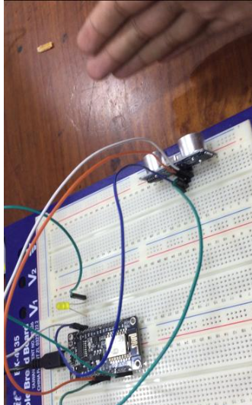

**Lab code:**

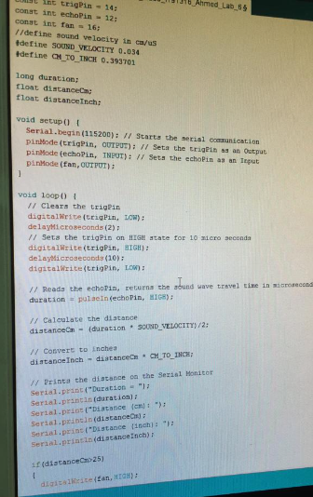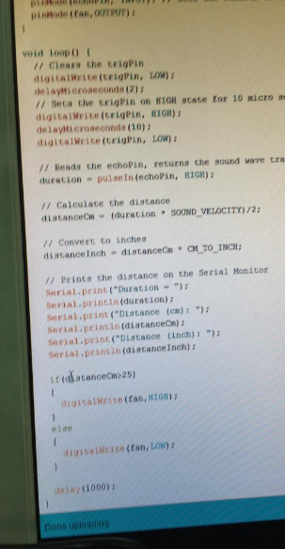

**Application:**

The Home Automation system based on the Internet of Things, also known as IoT, aims to control all of your smart home's devices using internet protocols or cloud computing. We'll sort IoT sensors for home automation by their ability to sense:

sensors for temperature.

Light sensors

Sensors for water level

Sensors for air composition.

Video surveillance equipment.

Sensors for voice and sound.

Sensors for pressure.

Sensors for humidity.

sensors that gather environmental data for the IoT system to process. Using an IP address, the device and the Internet of Things system can be connected and identified. Actuators that enable the devices to respond to data from their own sensors and feedback from the network.

**Issues:**

we never find any issue regarding this lab.

**Conclusion:**

In this lab we perform IoT (Internet of Things) based door and fan automation. We Integrate an ultrasonic sensor with an ESP8266 to detect a person standing in front of the door and set a reasonable range from which to open it for them.Your system should turn the door's motor, which is attached to the person, in a clockwise direction for a predetermined amount of time as soon as the person is detected to fully open the door.However, in order to completely reclose the door, the motor needs to rotate in the opposite direction of the clock once the ultrasonic sensor stops detecting.